
Research Report: Padv1 Message Test (acp-confidential-cadoc)
OCT 2022 DRI: Kelly Peterson CORE TEAM: Kevin FuPeter SergelJordan CainesKay JacksonKatie CoffeeLouis Vitti Nathan DinhLouis FioreMeghan Desai Research Brief

| Business Context

There are ~100M Cx US-wide that place <2 orders a month on DoorDash. These “Occasional Cx” represent a significant opportunity for growth for DD. If we are able to increase these users OF, we can not only grow DD GMV, we can make the DashPass value prop more compelling for these Cx and convert them into long term retained / DP users.
On 10/21, DoorDash will be running a new experiment exploring “total fees” and distance based pricing for both classic and DashPass Cx in Austin and Virginia Beach. For this experiment to be successful Cx must clearly understand the concept of total fees, the reasoning behind distance based pricing, and the cost savings associated with Nearby vs. Farther Away.

| Previous Research
The team has explored the needs of Occasional Cx and Feedback from EPIC 1 prior to this phase

- September Research Insights Monthly: Affordability Across the App (acp-confidential-cadoc)
- Churned Occasional Cx Research Report
- Churned Cx Flat Fee Test: Research Brief
- Why do Cx visitors drop-off? (US only) Q3 2022 | Part 1. Interview Insights

| Research Questions:
- What messaging/concepts will resonate the most with Cx? Which will have the greatest impact?
- Which messaging is most clear and believable for Cx?
- Which messaging should we bring forth for A/B testing on the 10/21 go live date?

| Methodology:
The Cx Research Team conducted an online survey with 146 classic customers. A MaxDiff was run and a TURF simulator was created to identify the top preferred messages for Classic Cx.

| Messages Tested

- Introducing everyday low fees. Enjoy a selection of restaurants with lower fees everyday.
- With everyday low fee options, you don’t have to wait for the next discount to save.
- We’re making it easy to know what to expect at checkout by showing you all fees upfront in one Total Fee.
- Plan your order more easily when you can see the Total Fee as you’re choosing what to order.
- Enjoy a simpler checkout experience. Delivery and Service Fees are now combined into one upfront Total Fee.
- Introducing Total Fees: fees are upfront and fixed so they don’t increase with your order subtotal.
- Fees based on distance mean that restaurants closer to you have lower fees. Less miles = lower fees!
- The shorter the distance, the less it costs you. Get lower fees from restaurants near you.
- More ways to save: get lower fees from restaurants closer to you.
- With distance based pricing, you pay less in fees for the restaurants nearest to you.

| TLDR Cx indicate they are more likely to order from DoorDash when exposed to messaging that speaks to savings. However, they find distance based pricing the easiest to understand and among the top most useful. Research recommends creating a combination of the following statements for GTM messaging:
- “Introducing everyday low fees. Enjoy a selection of restaurants with lower fees everyday” OR More ways to save: get lower fees from restaurants closer to you
- “The shorter the distance, the less it costs you. Get lower fees from restaurants near you” OR “Fees based on distance mean that restaurants closer to you have lower fees. Less miles = lower fees!”

| Survey Results

Rated Very Easy to Understand: Messages related to distance based pricing are the easiest for Cx to understand, followed by “everyday low fees” messages.
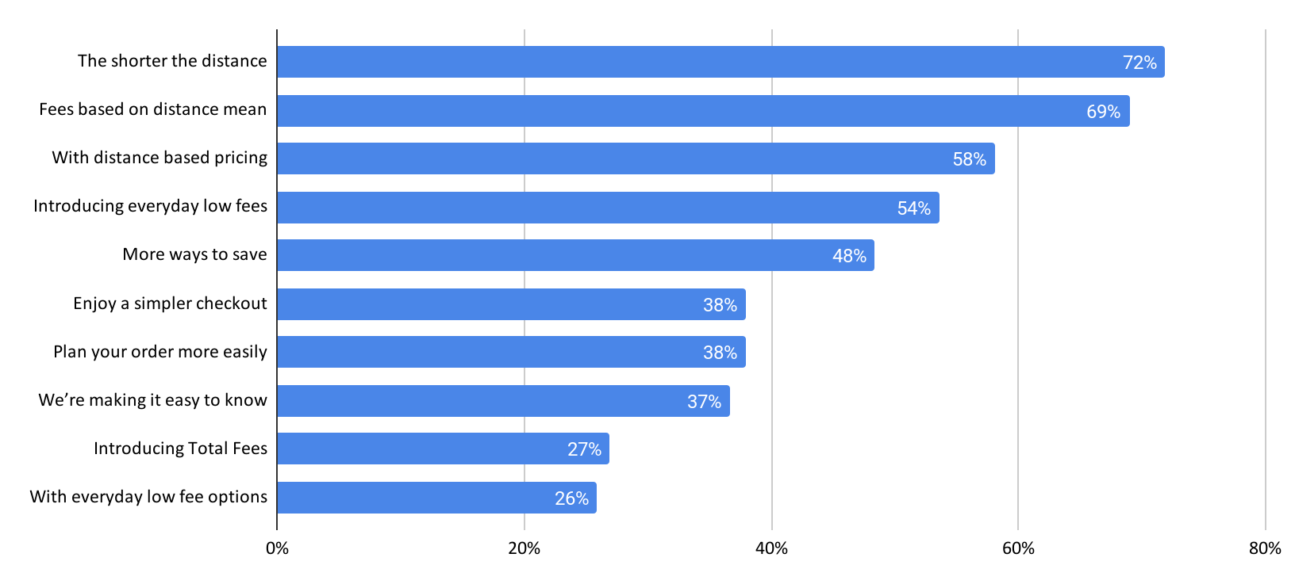

Rated Extremely Useful to Me Personally: Rating for usefulness are moderate overall with those messages related to distance based pricing having the strongest useful score.

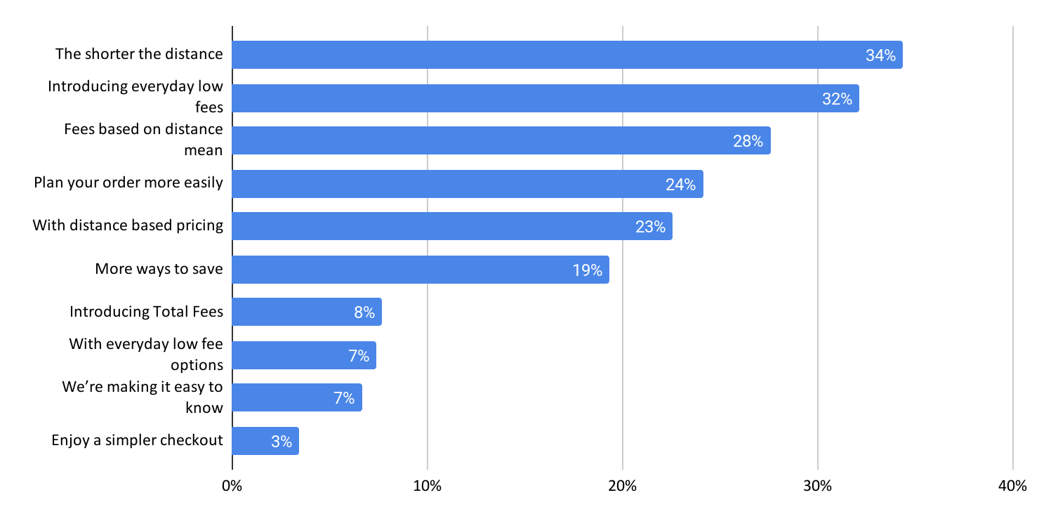

Rated Extremely Likely to Order in the Next Two Weeks: Rating for usefulness are moderate overall with those messages related to distance based pricing having the strongest useful score.
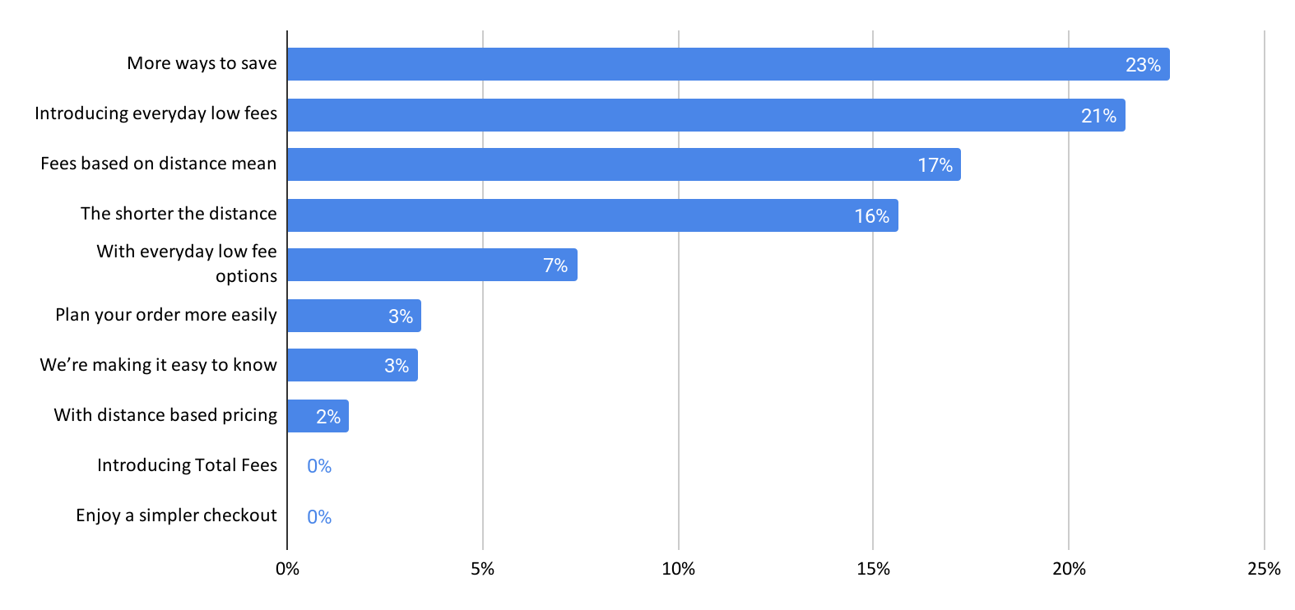

MaxDiff: Preference Share: Respondents tend to have a preference for messaging that references “everyday low fees”.
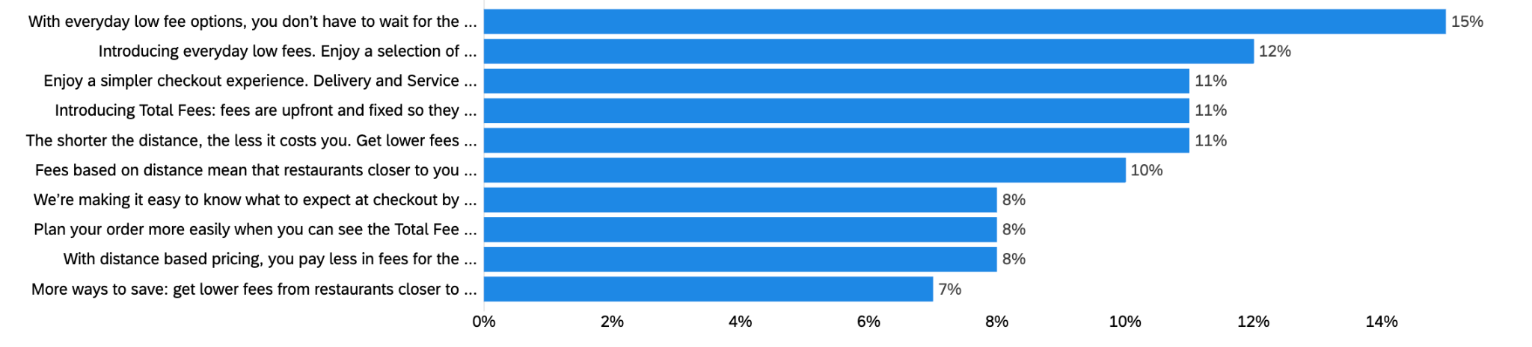
The preference share is measurement of the distribution of preference that respondents have for the tested attributes of the MaxDiff. The preference shares sum up to 100% and can be understood as the likelihood that the attribute truly is the most preferred item.

Please note: still building the FINAL turf simulator for the best message bundling options. Initial data indicates a hybrid of distance based and everyday savings would be best.

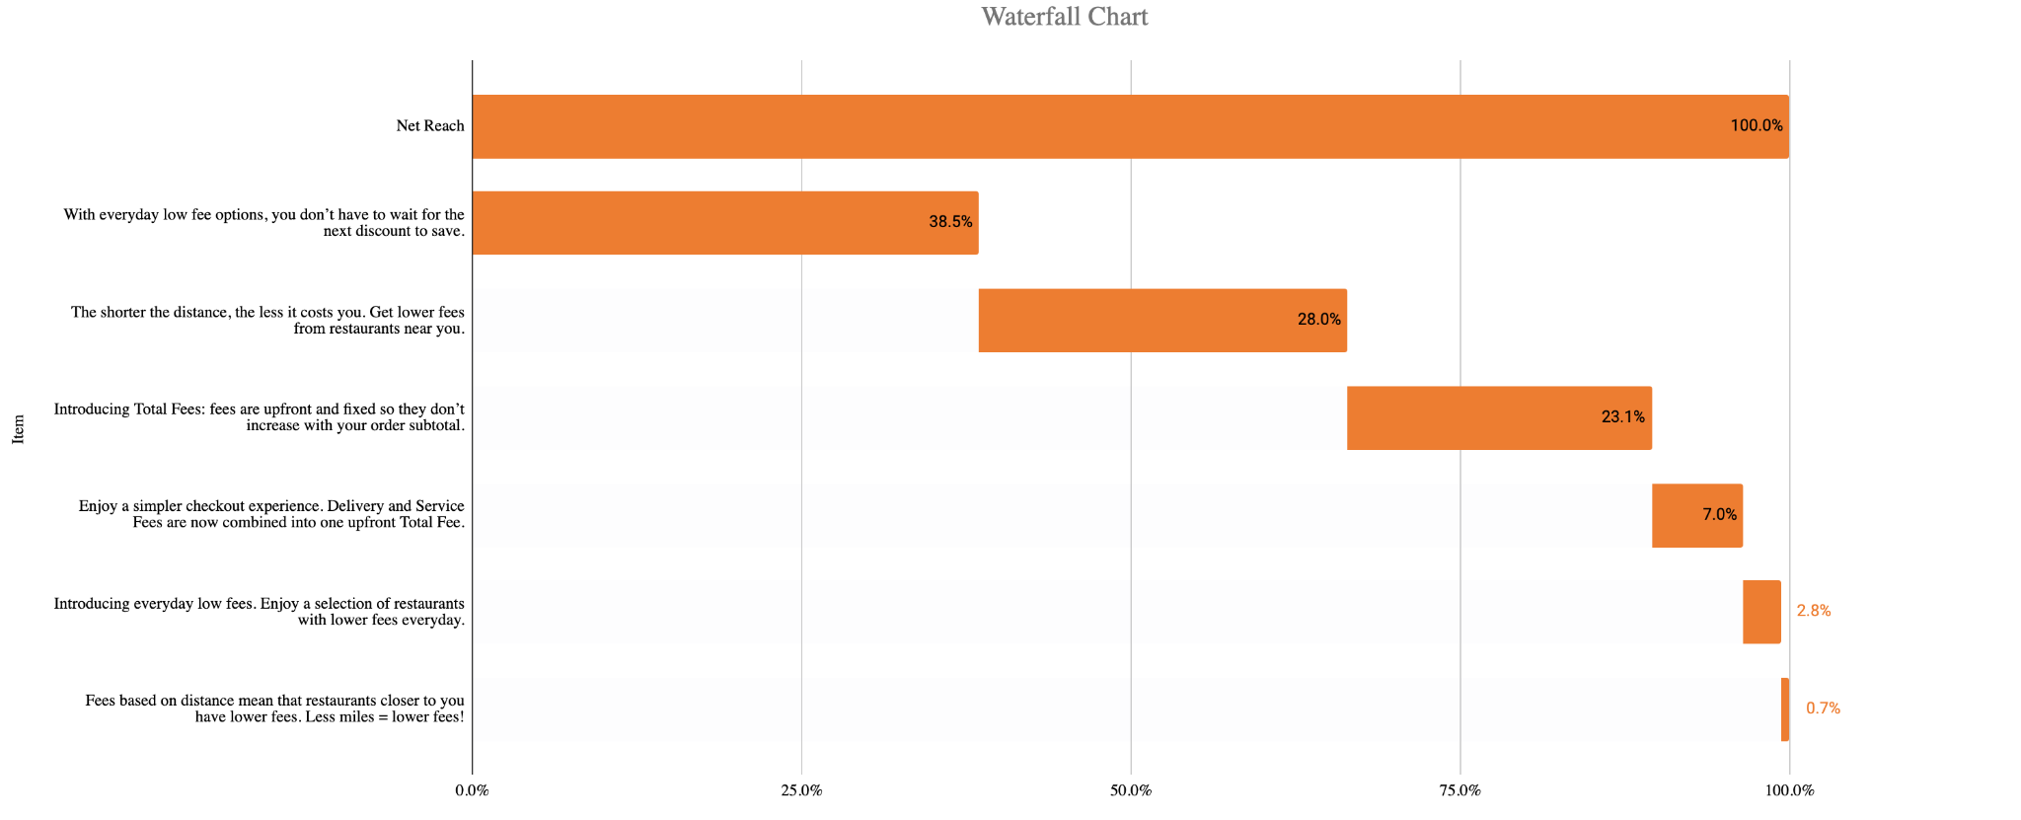

 | Single Item Reach | If Added | If Dropped
Introducing everyday low fees. Enjoy a selection of restaurants with lower fees everyday. | 35.0% |  | 35.0%
With everyday low fee options, you don’t have to wait for the next discount to save. | 38.5% | 14.7%
We’re making it easy to know what to expect at checkout by showing you all fees upfront in one Total Fee. | 27.3% | 24.5%
Plan your order more easily when you can see the Total Fee as you’re choosing what to order. | 24.5% | 20.3%
Enjoy a simpler checkout experience. Delivery and Service Fees are now combined into one upfront Total Fee. | 29.4% | 21.0%
Introducing Total Fees: fees are upfront and fixed so they don’t increase with your order subtotal. | 34.3% | 28.7%
Fees based on distance mean that restaurants closer to you have lower fees. Less miles = lower fees! | 30.8% | 23.8%
The shorter the distance, the less it costs you. Get lower fees from restaurants near you. | 34.3% | 29.4%
More ways to save: get lower fees from restaurants closer to you. | 27.3% | 16.1%
With distance based pricing, you pay less in fees for the restaurants nearest to you. | 18.9% | 16.8%

